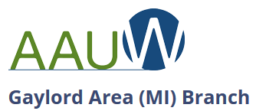 | Maureen Derenzy, Media Coordinator  Phone: (989) 350-4567 (cell)  Email: mderenzy@gmail.com  September 17, 2018

Press Release

AAUW seeking donations for annual book sale
Gaylord – If your gently used books, DVDs, and music CDs are taking up too much space in your home and you have been wondering how to solve that problem, read on! Now is the perfect time to consider a donation to the American Association of University Women (AAUW) Gaylord Area Branch book sale. Beginning September 19th, donations can be dropped off at blue collection barrels located at Family Fare, Oliver Chiropractic, the United Way Building, Gordon Food Service and Meyer Ace Hardware. Persons seeking more information or needing a special pickup can call book sale chairperson Mary Tomaski at 732-4981.
Proceeds from the sale support education awards for girls and women who are going to college or acquiring new skills. The sale will take place at the United Way Building on Friday, October 5th from 9:00 am to 6:00 pm and on Saturday, October 6th from 9:00 am to noon.
All categories of books, music and movies are welcome, with the exception of textbooks, and outdated audiocassette and videocassette (VCR) formats.
AAUW is a nationwide organization that advances equity and education for women and girls. The Gaylord Area Branch empowers through education awards, educational programs and honoring the achievements of local women. For more information, visit gaylord-mi.aauw.net or email aauwgaylord@gmail.com.

####

